**EXERCISE -** 2

**INTRODUCTION TO JAVA**

**Aim:** Write a java program to print an integer

**File name:** demo1.java

**Program:**

**//HELLO**

**import java.lang.*;**

**class Demo{**

**public static void main(String args[]){**

**int a = 6;**

**System.out.print("a value is:"+a);**

**}**

**}**

**Output:**

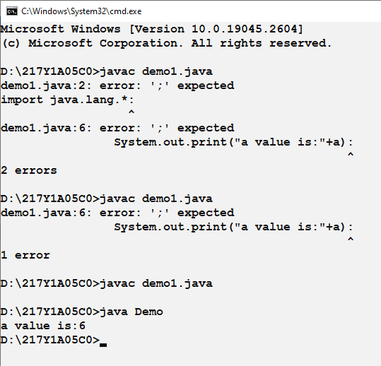

**Aim:** Write a java program to perform arithmetic operations on two numbers

**File name:** demo2.java

**Program:**

**//HELLO**

**import java.lang.*;**

**class Demo{**

**public static void main(String args[]){**

**int a = 6,b = 7;**

**System.out.println("a + b is:"+(a+b));**

**System.out.println("a - b is:"+(a-b));**

**System.out.println("a * b is:"+(a*b));**

**System.out.println("a / b is:"+(a/b));**

**System.out.println("a % b is:"+(a%b));**

**}**

**}demo2.jav**

**Output:**

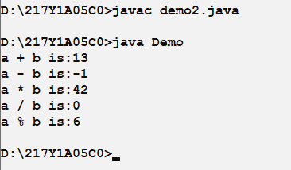

**Aim:** Write a java program to perform simple for loop

**File name:** demo3.java

**Program:**

**//HELLO**

**import java.lang.*;**

**class Demo{**

**public static void main(String args[]){**

**int a = 10,i;**

**for(i = 0;i < a;i++){**

**System.out.println(i+",");**

**}**

**}**

**}**

**Output:**

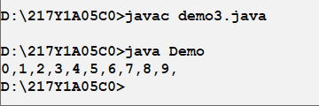

**Aim:** Write a java program to print multiplication table

**File name:** demo4.java

**Program:**

**//HELLO**

**import java.lang.*;**

**class Demo{**

**public static void main(String args[]){**

**int a = 10,i;**

**for(i = 0;i <= a;i++){**

**System.out.println(a+" * "+i+" = "+(a*i));**

**}**

**}**

**}**

**Output:**

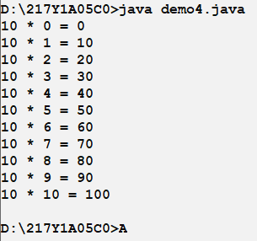

**Aim:** Write a java program to print factorial of 7

**File name:** demo5.java

**Program:**

**//HELLO**

**import java.lang.*;**

**class Demo{**

**public static void main(String args[]){**

**int fact=1,i,n=7;**

**for(i = 1;i <= n;i++){**

**fact = fact*i;**

**}**

**System.out.print(fact);**

**}**

**}**

**Output:**

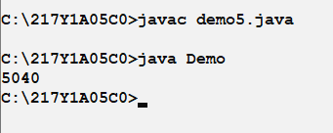

**Aim:** Write a java program to print 1st 12 fibonacci series

**File name:** demo6.java

**Program:**

**//HELLO**

**import java.lang.*;**

**class Demo{**

**public static void main(String args[]){**

**int a = 0,b=1,c,i;**

**System.out.print(a+","+b);**

**for(i = 0;i < 10;i++){**

**c=a+b;**

**System.out.print(","+c);**

**a=b;**

**b=c;**

**}**

**}**

**}**

**Output:**

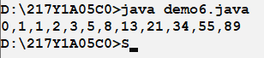

**Aim:** Write a java program to perform simple input program

**File name:** demo7.java

**Program:**

**//HELLO**

**import java.lang.*;**

**import java.util.*;**

**class Demo{**

**public static void main(String args[]){**

**Scanner S=new Scanner(System.in);**

**int age;**

**System.out.print("Enter age:");**

**age = S.nextInt();**

**if (age>=18){**

**System.out.print("Eligible for voting");**

**}**

**else{**

**System.out.print("Not eligible for voting");**

**}**

**}**

**}**

**Output:**

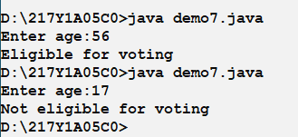

**Aim:** Write a java program to read and print ROLL NUMBER of student

**File name:** demo8.java

**Program:**

**//HELLO**

**import java.lang.*;**

**import java.util.*;**

**class Demo{**

**public static void main(String args[]){**

**Scanner S=new Scanner(System.in);**

**String rollno;**

**System.out.print("Enter rollno:");**

**rollno = S.nextLine();**

**System.out.print(rollno);**

**}**

**}**

**Output:**

